Setting up Google Drive Account:
Go to www.google.com and sign in using your EVSC gmail account:
  - Your login is: firstname.lastname@evsck12.com
    - Example: Natalie.renner@evsck12.com
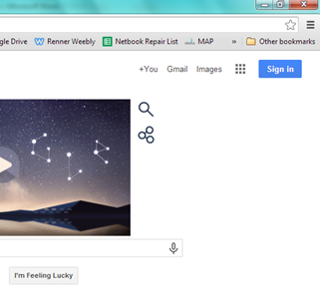
  - Your password: same as your computer login

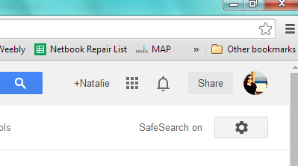

Then Click on this icon:

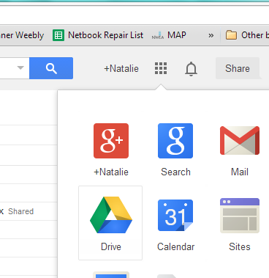
Click on the Google Drive Icon:

Create a Google Drive Folder – click on “create” button & then the folder button from the drop down menu
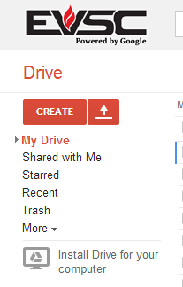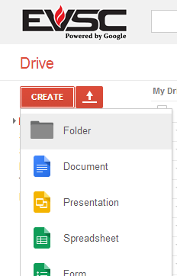
  - Name the folder”# Lastname, Firstname English”
    - Example: if you are in 4th period, your folder name would be: 4 Smith, Joe English
  - Once the folder is created, You must share the folder with Ms. Renner (Natalie.renner@evsck12.com)
    - This gives Ms. Renner viewing/editing/grading rights to all your files
